Integration Documentation
1. Introduction
This document explains how my banking system project is integrated from the GUI to the data storage. The project has four main layers: GUI (JavaFX), Controllers, Domain Model (Customer, Teller, Account), and File I/O (TXT files).
I faced a few challenges during integration — mainly making the GUI talk to the controllers correctly and figuring out how to read/write files without breaking the system. I’ll explain these struggles in each section.
2. System Architecture Overview
The system is organized into four layers:
- Boundary Layer (GUI/FXML)
  - Screens: Login, Teller Dashboard, Customer Dashboard, Account Operations
  - Handles user input and displays information
  - Struggle: I initially had buttons that did nothing because the fx:id in FXML didn’t match the controller. Fixed it after carefully checking names.
- Controller Layer
  - Classes: LoginController, TellerDashboardController, CustomerDashboardController
  - Handles user actions from the GUI, calls domain model, and talks to data access classes
  - Struggle: Figuring out how to pass information between controllers (like which customer logged in) was tricky. I solved it by using method parameters instead of trying to store state in static variables.
- Domain Model Layer
  - Core objects: Customer, Teller, Account
  - Contains logic like deposits, withdrawals, account creation
  - Struggle: I kept forgetting to update the balance in both the Account object and the text file. Now I always write to the file immediately after any operation.
- Data Access Layer (File I/O)
  - Classes: CustomerDataAccess, TellerDataAccess, AccountDataAccess
  - Files: customers.txt, tellers.txt, accounts.txt
  - Reads/writes data to text files
  - Struggle: Initially tried reading files line-by-line without splitting properly, which caused crashes when parsing numbers. Fixed it with split(",") and parsing carefully.

3. Layer Responsibilities
Layer | Responsibilities | Struggles
GUI | Displays info, takes input | Button events didn’t match controller
Controller | Handles logic & calls model/data | Passing logged-in customer info
Domain Model | Business logic & data objects | Keeping objects and files in sync
Data Access | Reads/writes .txt files | Parsing strings correctly, handling missing files

- Sequence Diagram
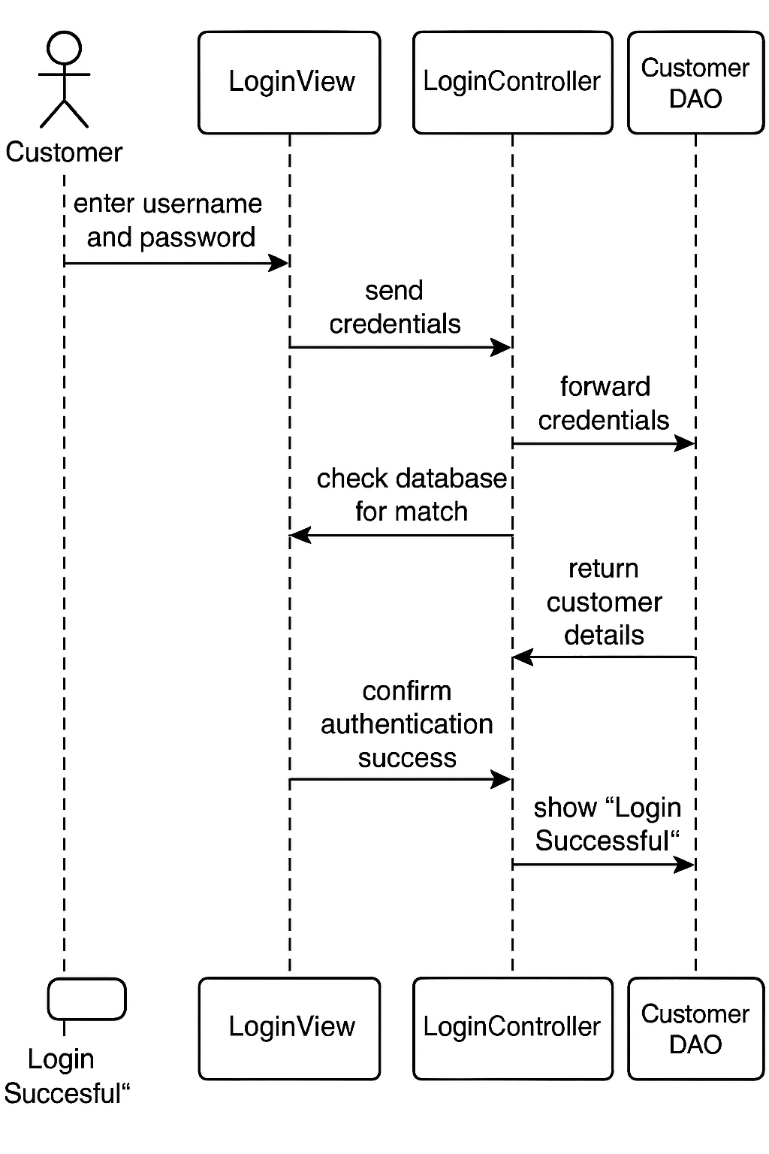
- State Diagram
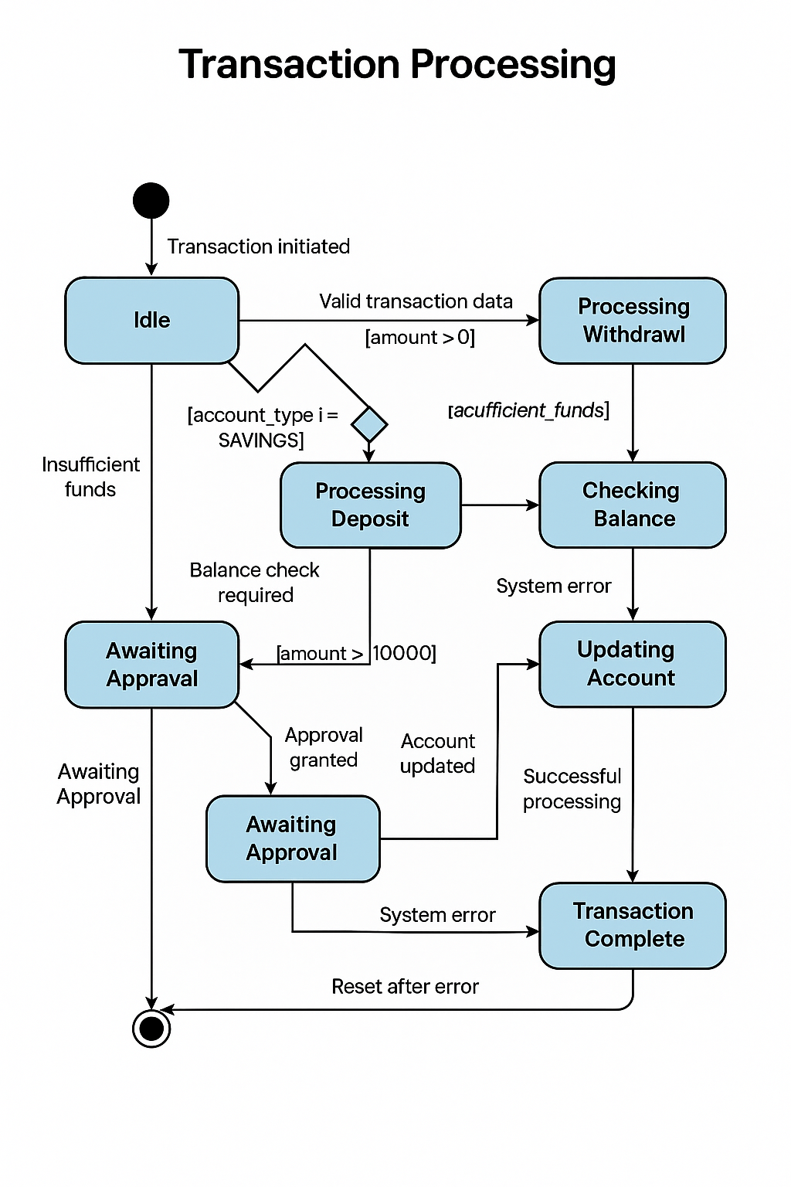
6. Integration Flow
- User enters credentials in Login GUI
- LoginController captures input and calls CustomerDataAccess.validateLogin()
- CustomerDataAccess reads customers.txt and validates credentials
- On success, Controller opens CustomerDashboard
- Dashboard uses AccountDataAccess.readAccounts(customerID) to fetch accounts
- Accounts are displayed in GUI

7. File Formats
- customers.txt → CustomerID,FirstName,Surname,Email,Password
- tellers.txt → TellerID,FirstName,Surname,Password
- accounts.txt → AccountNumber,CustomerID,Balance,AccountType
Error Handling:
- Invalid login → alert dialog
- Withdraw more than balance → alert and block operation
- Missing file → program creates empty file automatically

📗 Integration Testing Report
Test Scenario: Customer Login & Check Accounts
- Objective: Test full system integration from GUI → Controller → Domain Model → File I/O → GUI
- Input:
  - Username: cust01
  - Password: pass123
Step-by-Step Flow
- User types credentials in Login GUI
- LoginController calls CustomerDataAccess.validateLogin()
- customers.txt is read and matched
- On success, CustomerDashboard opens
- Dashboard calls AccountDataAccess.readAccounts(customerID)
- Accounts retrieved from accounts.txt
- GUI displays account info
Struggles:
- Dashboard didn’t display accounts until I filtered by customerID
- Buttons for deposit/withdraw didn’t work initially because their fx:id was wrong
Expected Output
- Login successful
- CustomerDashboard shows correct account balances
Actual Results
- Login works
- Dashboard shows accounts correctly
- Deposits and withdrawals update both file and GUI
Conclusion
- The system is fully integrated
- GUI, controllers, domain model, and File I/O work together
- Error handling works for login, insufficient funds, and missing files
- Learned a lot about debugging JavaFX and file handling

